Type the Title of the Paper



**Manuscript Template**

2018XXXX

16mm

- Type the Subtitle of the Paper -

**Main author’s Name 1)  Co-author’s Name 2)**

*1)Sociey of Automotive Engineers,*

*Inc., 10-2 Gobancho, Chiyoda, Tokyo, 102-0076, Japan (E-mail: taro@jsar.or.jp)*

*2) JSAE University, Graduate School of Engineering,*

**④**

*1-1 Sanbancho, Chiyoda, Tokyo, 102-0033, Japan*

Presented at the EVTeC and APE Japan on May XX, 2016

**ABSTRACT**: Explain the essential points in 100 words or less.

**KEY WORDS**: heat engine, spark ignition engine, combustion analysis, Flame,Electric Fields (A1)

**1. Introduction**

Clearly describe the purpose, contents, and conclusion of the research, while complying with the ethical guidelines of the JSAE. Company and product names, terminology whose usage is restricted to within a particular company, and commercial content may not be included in the main text..

**2. SECTION TITLE**

**2.1. Subheading**

Clearly describe the purpose, contents, and conclusion of the research, while complying with the ethical guidelines of the JSAE. Company and product names, terminology whose usage is restricted to within a particular company, and commercial content may not be included in the main text..

**2.2. Subheading**

Type the contents of the section here.

**2.2.1. Sub-subheading**

Type the contents of the section here.

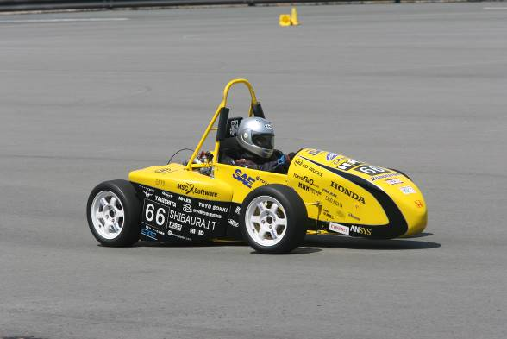

Fig. 1 Type the Caption Here.

Table 1 Type the Caption Here.



**2.2.2. Sub-subheading**

Type the contents of the section here.

Note for “References” is indicated in “REFERENCES” as below(1)



Fig.2 A Bar Graph

**3. CONCLUSION**

Type the contents of the conclusion here.

**References**

References are listed after the main text of the paper. Where a reference is cited, enter the superscripted number of the reference in parentheses at the appropriate location in the text. The format for reference entries is described in SIST 02-2007.

(1) Taro Jidosha: Vehicle Dynamics System, SAE Technical Paper 0000-01-2345 (2014)

(2) Michel J. Fox：Template for Proceedings, Part I: Rules and Guidelines for Presentations, First Issue, p.100-104 (2004).